

**Faculty of engineering - Shoubra**

**Benha University**

**Research Article / Research Project / Literature Review**

in fulfillment of the requirements of

|  |  |
| --- | --- |
| **Department** | **Engineering Mathematics and Physics** |
| **Division** | **-----------------** |
| **Academic Year** | **2019-2020 Preparatory** |
| **Course name** | **Computer** |
| **Course code** | **ECE001** |

**Title: -**

**Big Data**

By:

|  |  |  |  |
| --- | --- | --- | --- |
|  | Name | Edu mail | B.N |
| 1 | Abdallah Khaled Abdallah Khaled | Abdallah 1955420@feng.bu.edu.eg | 487 |

**Approved by:**

|  |  |
| --- | --- |
| Examiners committee | Signature |
| Dr.Ahmed Bayoumi |  |
| Dr.Shady Elmashad |  |
| Dr. Abdelhamid Attaby |  |
|  |  |
|  |  |

**screenshots :**

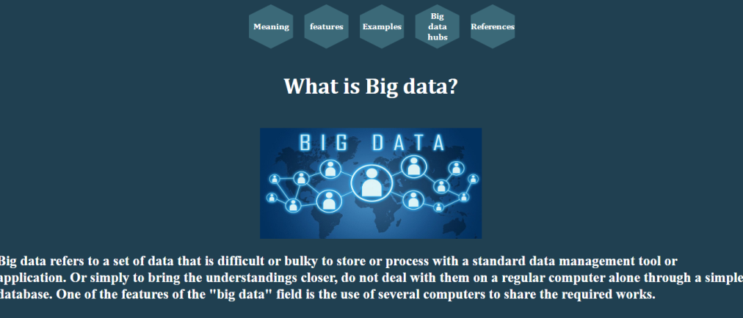

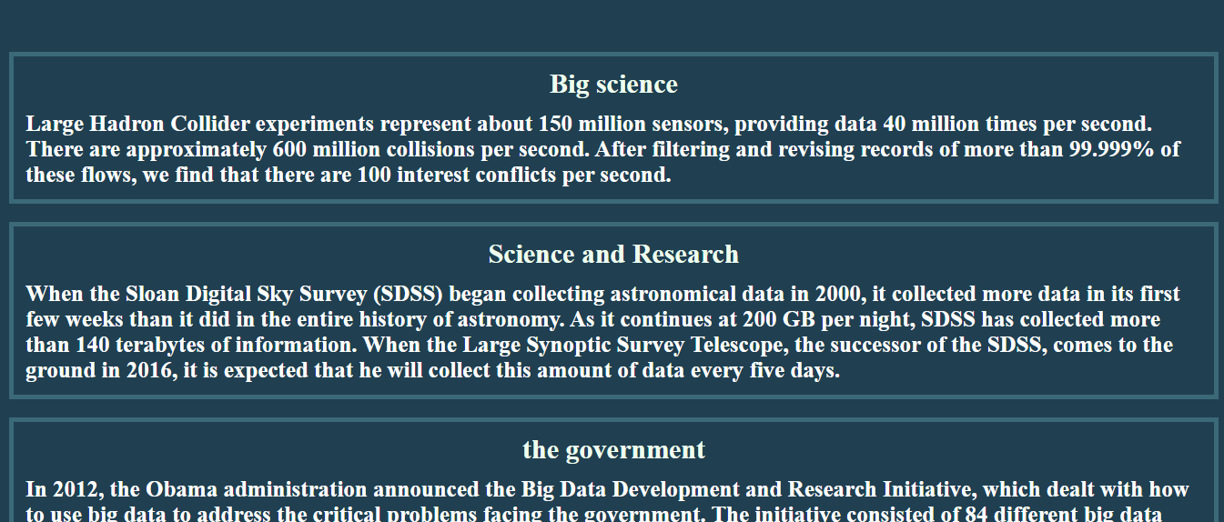

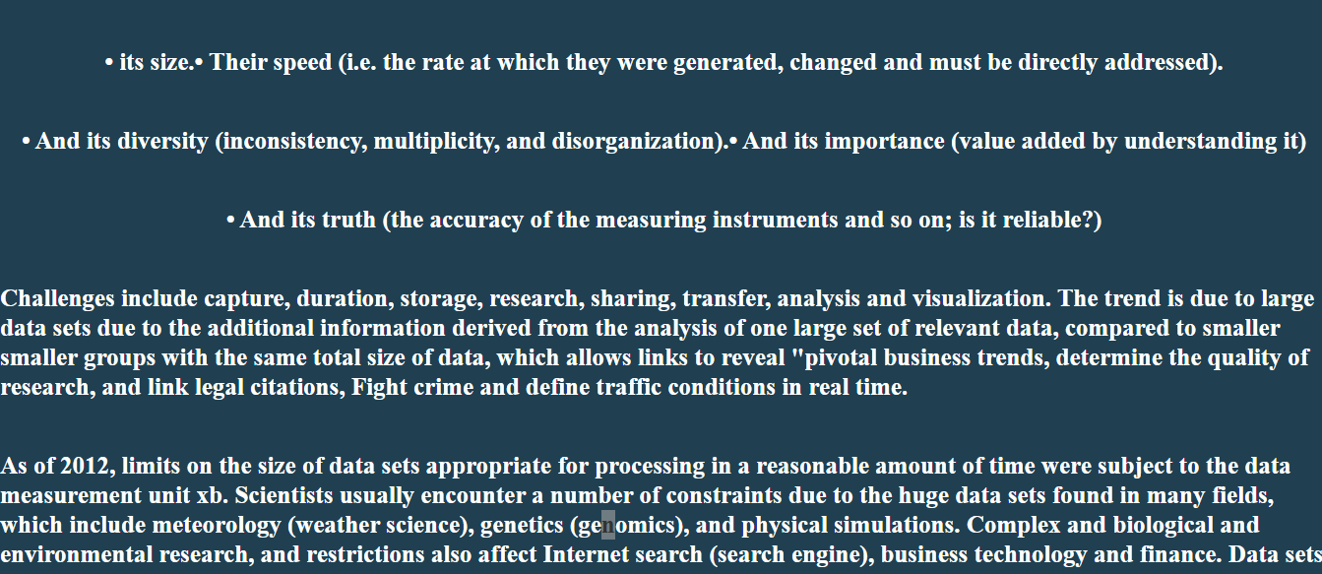

**Source Code :**

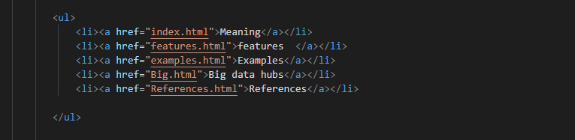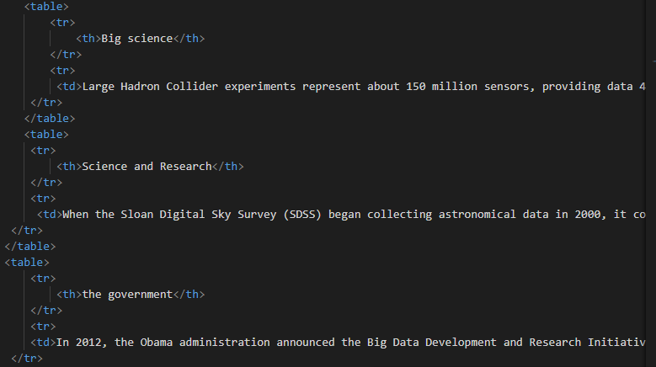

**github link :** [**https://abdallah-khaled-abdallah.github.io/abdallah-khaled/**](https://abdallah-khaled-abdallah.github.io/abdallah-khaled/)